AWS – Key Management Service

Title
Encrypting an Amazon S3 Bucket Using AWS Key Management Service (KMS)

What is this and why we need it
By default, data stored in Amazon S3 can be accessed by anyone who has permission to the bucket. In real-world DevOps and production environments, data must be encrypted at rest to meet security, compliance, and organizational standards.
AWS Key Management Service (KMS) allows us to create and manage encryption keys that AWS services use to encrypt data. By integrating KMS with S3, we ensure that every object stored in the bucket is encrypted using a secure and controlled encryption key. This prevents unauthorized access to sensitive data even if storage access is compromised.

Objective
To secure data stored in an Amazon S3 bucket by enabling server-side encryption using a customer-managed AWS KMS key, ensuring strong data protection and compliance from a DevOps perspective.

Prerequisites
- AWS account
- IAM user with permissions for S3 and KMS
- AWS region selected (example: us-east-1)
- A customer-managed KMS key already created (example: kms-demo-key)

Create a KMS Key (STARTING POINT)
- Login to AWS Management Console
- In search bar, type KMS
- Click Key Management Service
- In left menu, click Customer managed keys
- Click Create key
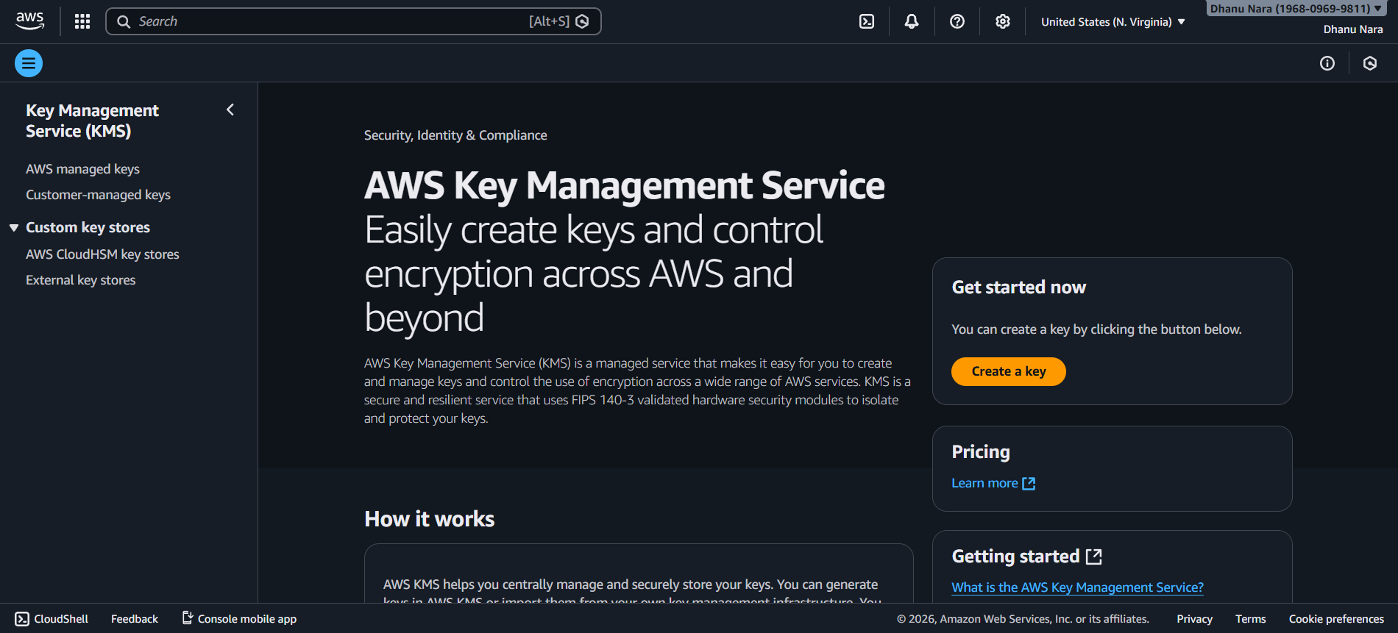

Configure KMS Key
- Key type → Select Symmetric
- Key usage → Select Encrypt and decrypt
- Click Next

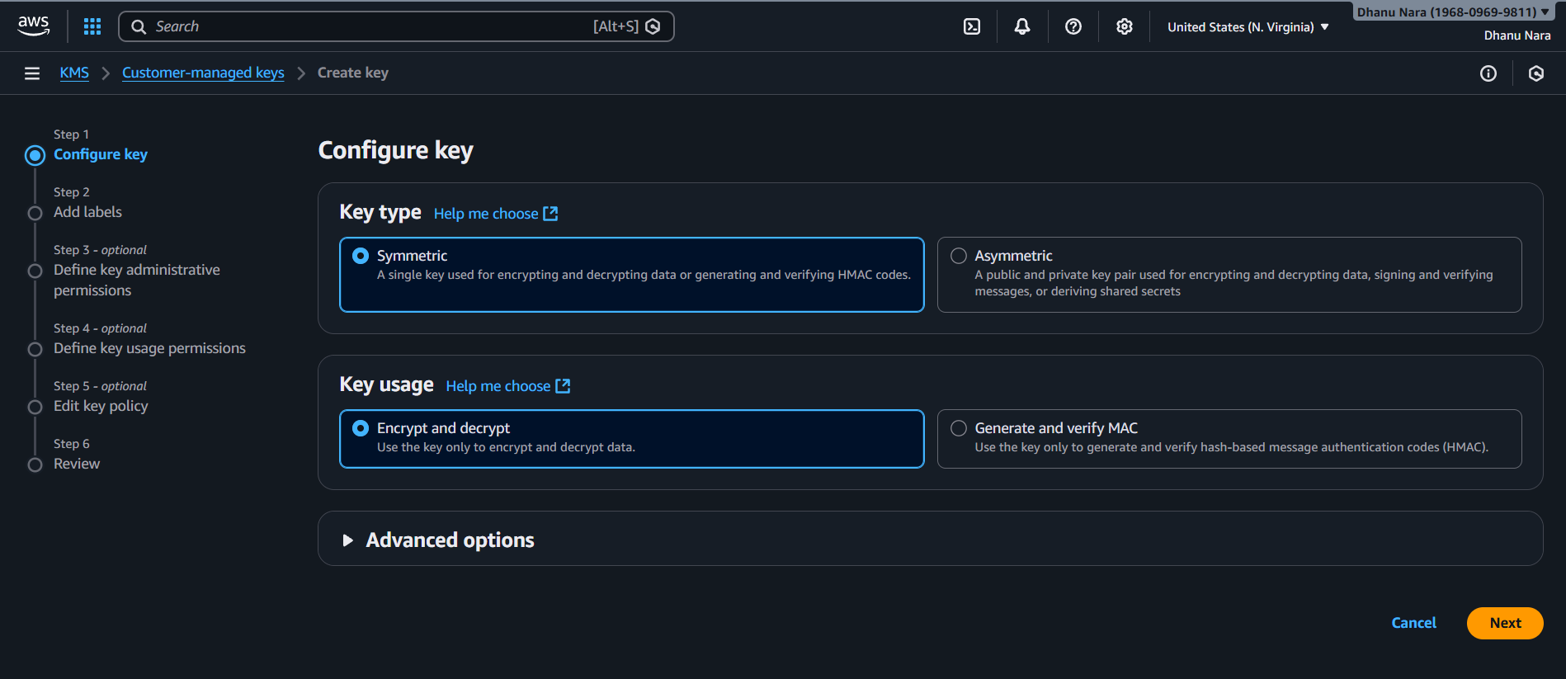

Add Alias and Description
- Alias → kms-s3-encryption-key
- Description → KMS key for encrypting S3 bucket
- Click Next

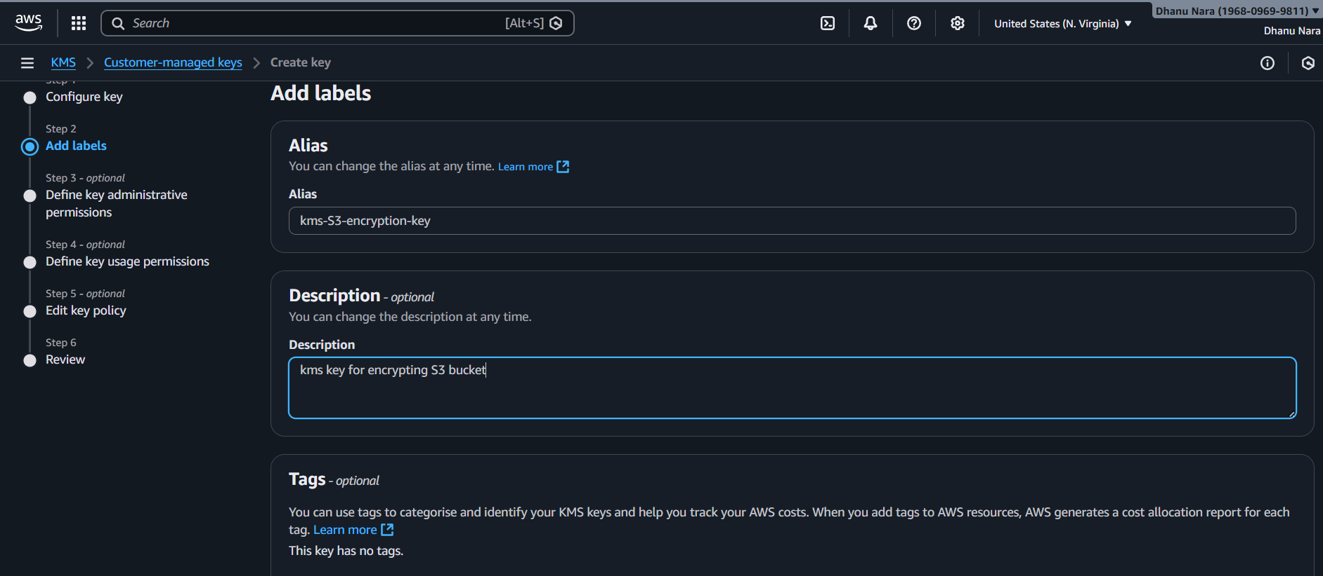

Define Key Administrators
- Select your IAM user
- This allows you to manage the key
- Click Next
Define Key Usage Permissions
- Select your IAM user
- This allows you to use the key for encryption
- Click Next
Review and Create Key
- Review configuration
- Click Finish
✅ KMS key is now created

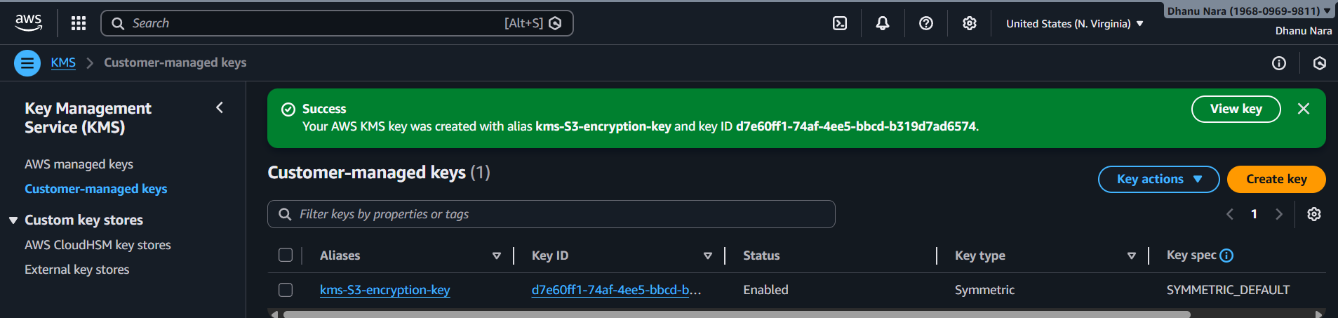

Create an S3 Bucket
- In AWS search bar, type S3
- Click Amazon S3
- Click Create bucket
Configure Bucket Details
- Bucket name → kms-encrypted-s3-demo (must be unique)
- Region → Same region as KMS key
- Leave all other options as default
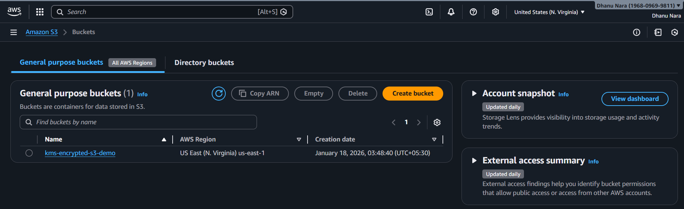

Enable KMS Encryption on S3 Bucket
- Scroll down to Default encryption
- Enable Server-side encryption
- Encryption type → Select AWS Key Management Service (KMS)
- KMS key → Select Customer managed key
- Choose key → kms-s3-encryption-key
This ensures every file uploaded is encrypted automatically

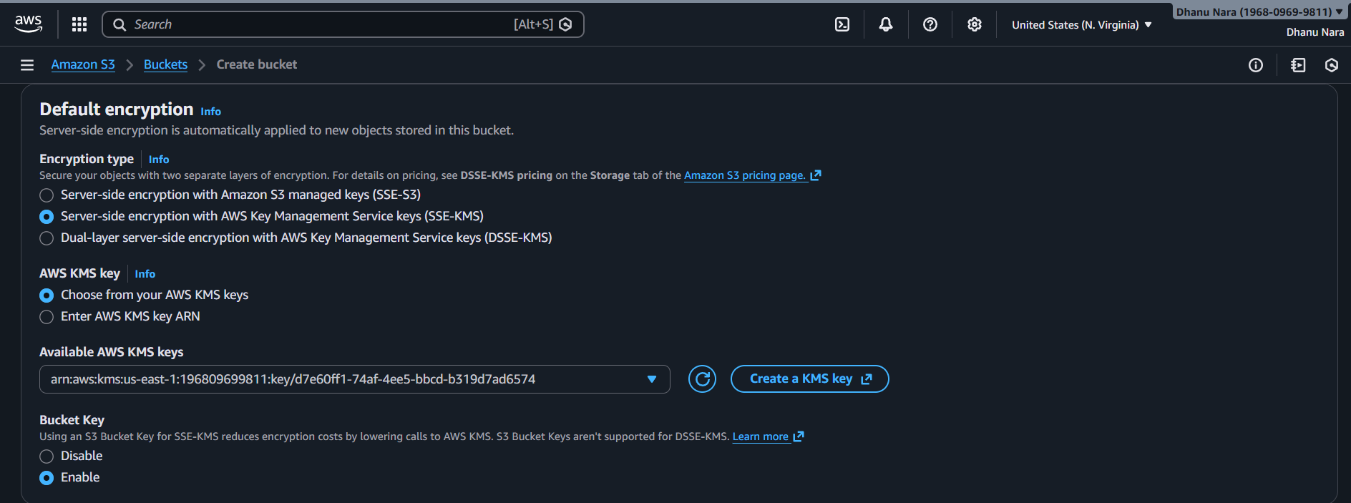

Upload a File (Verification)
- Open the created bucket
- Click Upload
- Upload any file
- Click Upload

Verify Encryption
- Click the uploaded file
- Open Properties
- Check Server-side encryption
- It should show:
AWS-KMS – kms-s3-encryption-key
✅ Encryption verified

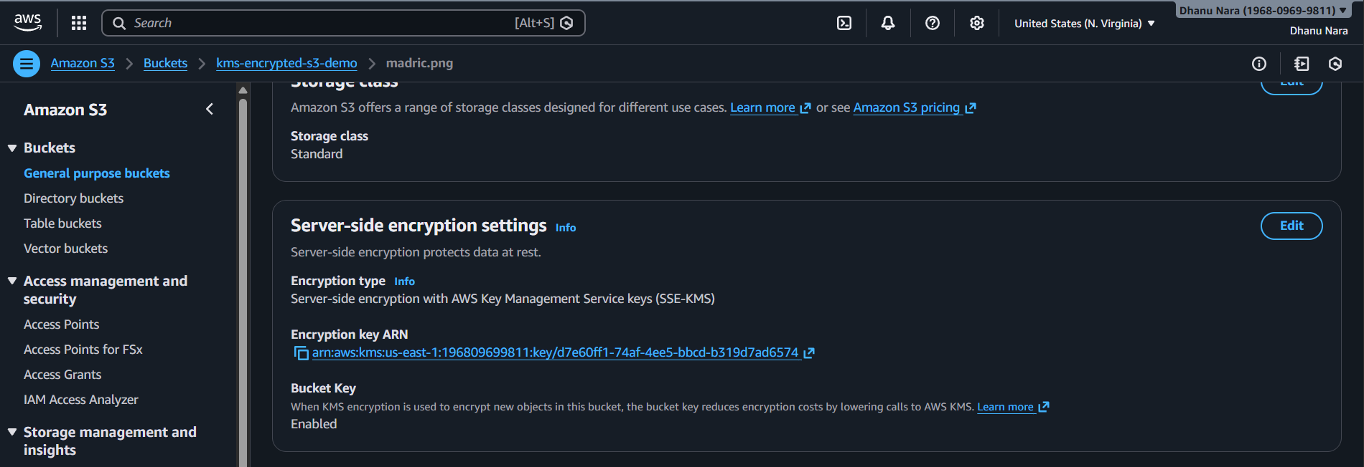

Conclusion
Using AWS KMS to encrypt an S3 bucket ensures strong data-at-rest security and centralized key control.
This approach is a DevOps best practice for protecting sensitive data and meeting security and compliance requirements.

AWS – Secret Manager

Title
Secure Credential Management Using AWS Secrets Manager

What is this and why we need it
By default, application credentials such as database usernames, passwords, and API keys are often stored in code files, configuration files, or environment variables. In real-world DevOps and production environments, this creates a major security risk and can lead to accidental exposure of sensitive data.
AWS Secrets Manager allows us to securely store, manage, and retrieve sensitive information by encrypting it using AWS Key Management Service (KMS). By integrating Secrets Manager with applications and AWS services, credentials are accessed securely at runtime, ensuring that secrets are protected, auditable, and not exposed even if application code or infrastructure is compromised.

Objective
To securely store sensitive information such as database credentials using AWS Secrets Manager and retrieve them programmatically from an AWS Lambda function.

Prerequisites
- An active AWS account with required permissions
- Basic understanding of AWS IAM, Lambda, and Secrets Manager
- An IAM role with permission to access AWS Secrets Manager
- AWS Lambda service enabled in the selected region
- A secret created in AWS Secrets Manager with proper key–value pairs

Open AWS Secret Manager
- Login to AWS Console
- Search for Secrets Manager
- Click Secrets Manager

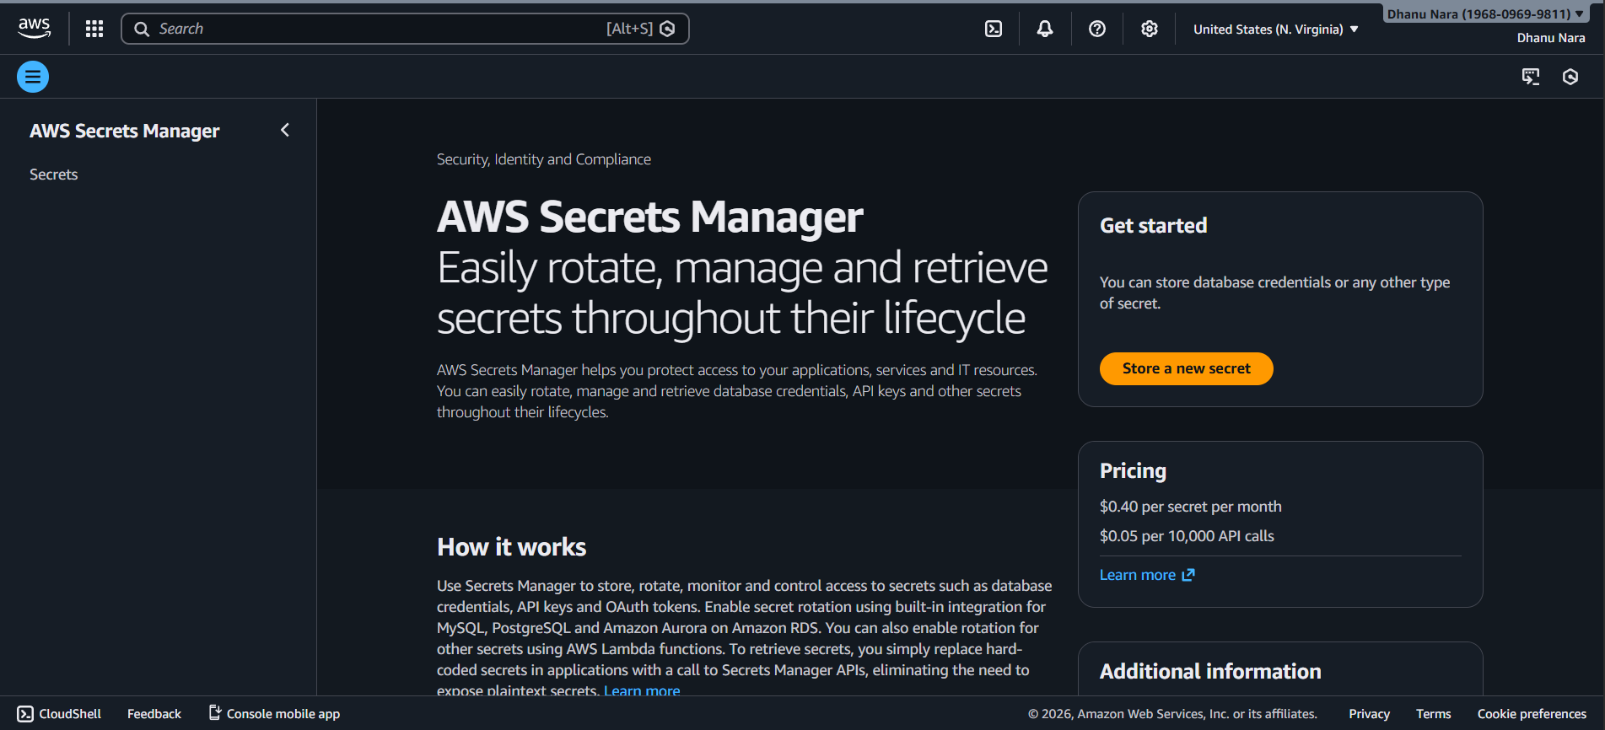
Create a new secret
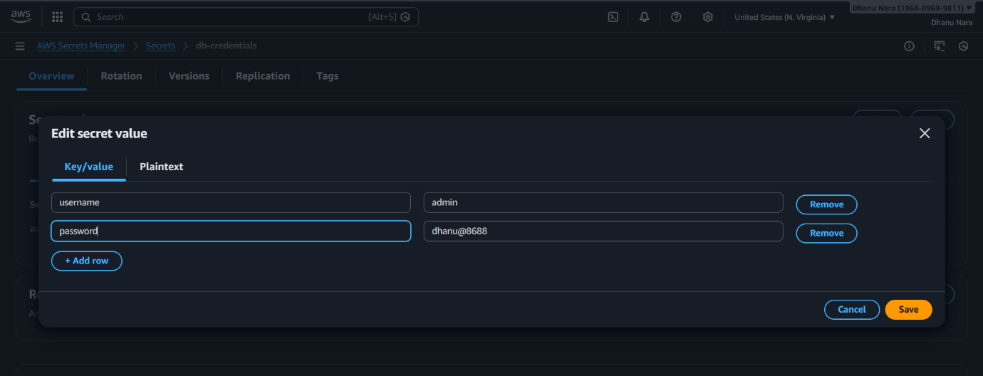
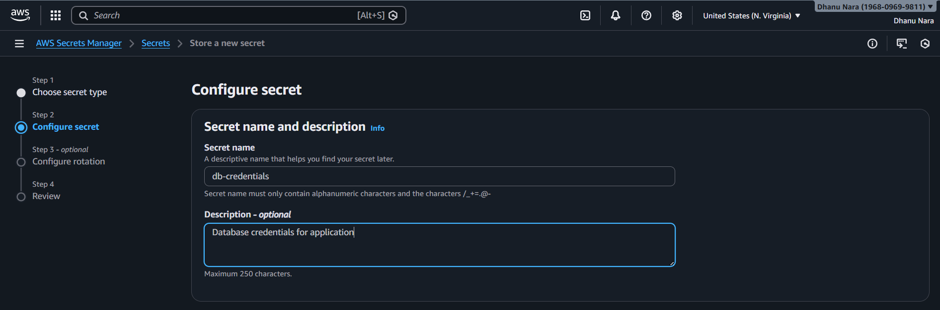

Rotation Settings
- Disable automatic rotation (for now)
- Click Next
Review & Create
- Review details
- Click Store
Secret created successfully

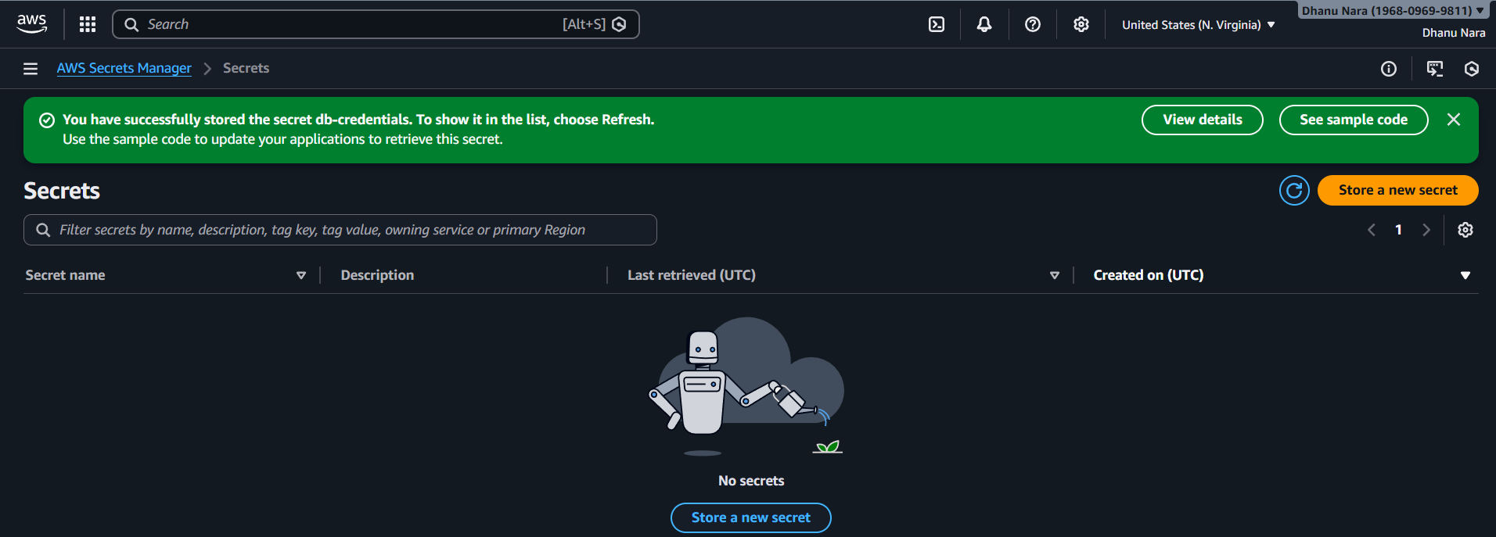

Create Lambda Function
- Go to AWS Lambda
- Click Create function

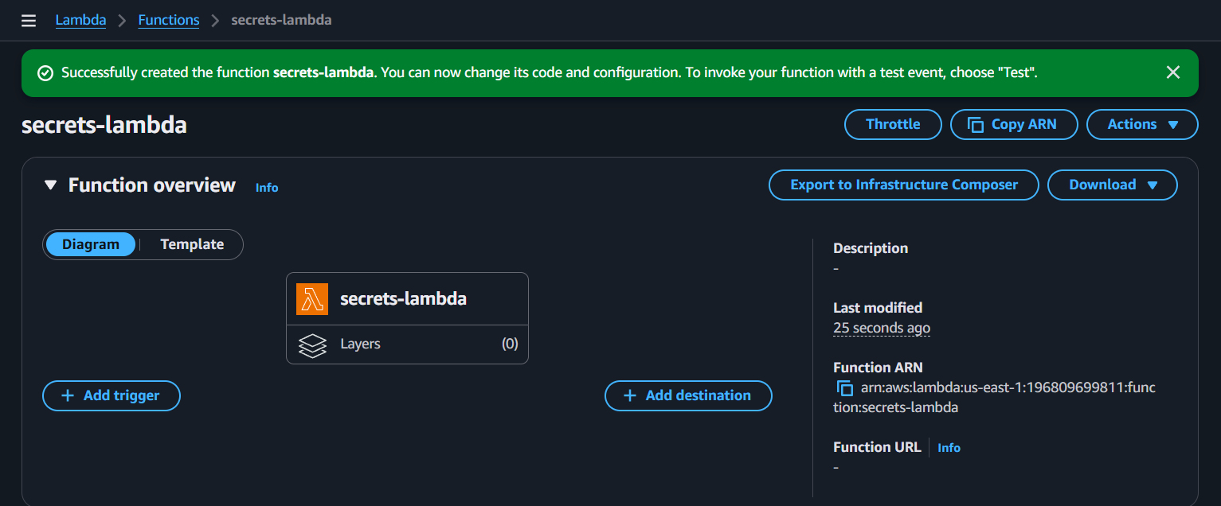

Add permission to access Secrets
- Go to IAM
- Open the Lambda execution role
- Attach policy:
SecretsManagerReadWrite

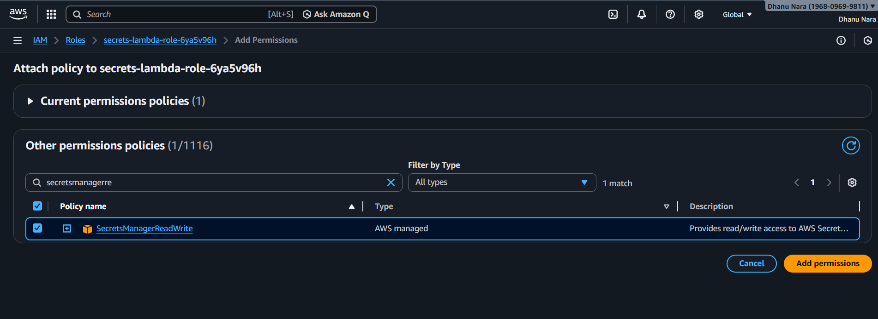

ADD LAMBDA CODE (RETRIEVE SECRET)
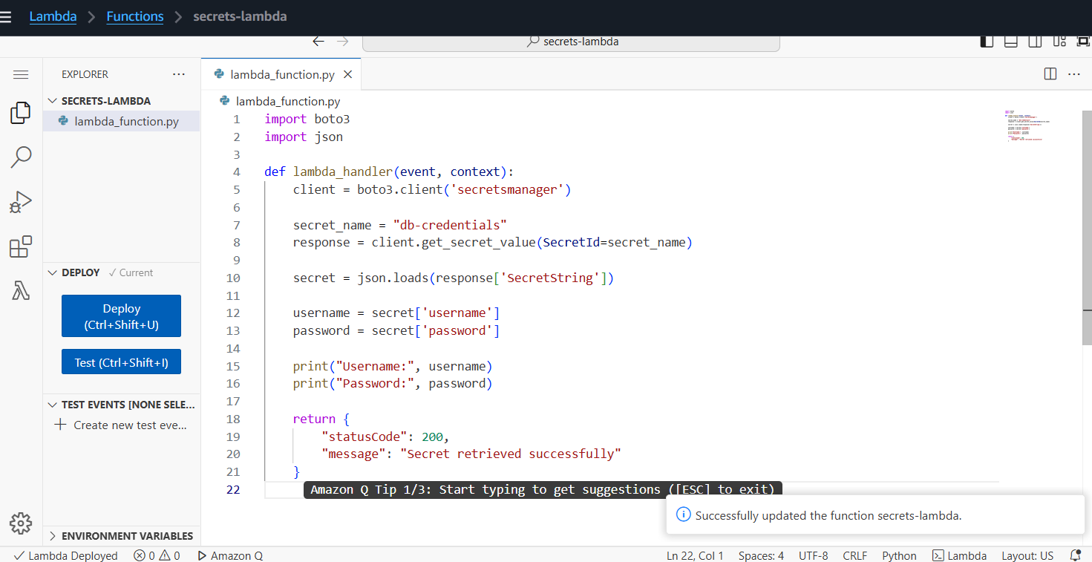

Test the Lambda
- Click Test
- Create a test event (any JSON)
- Click Run

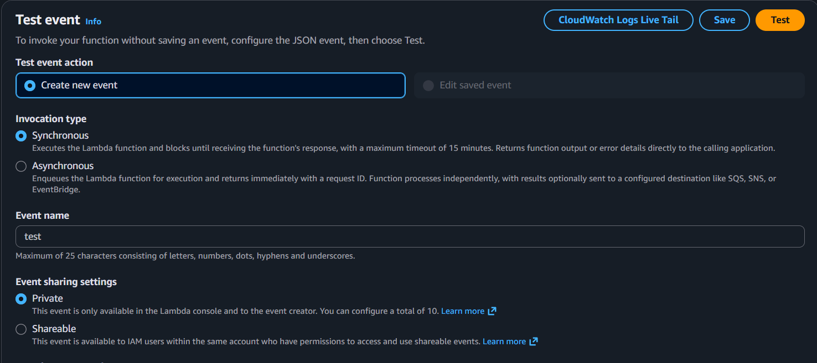
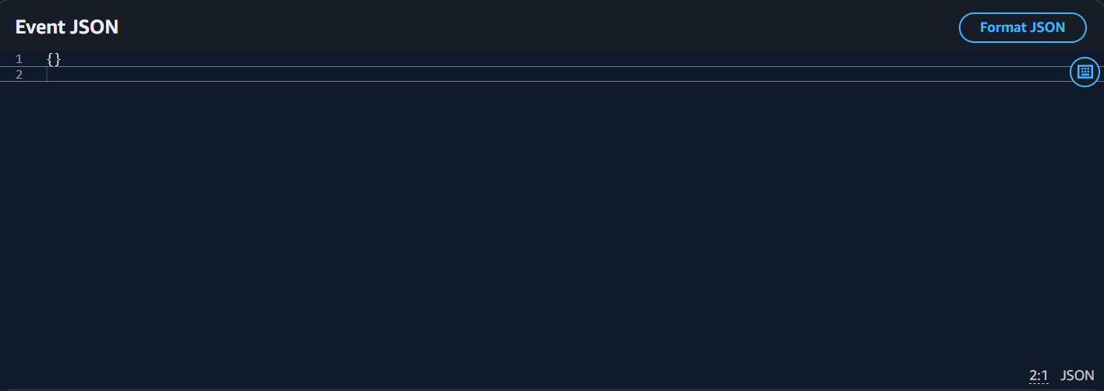
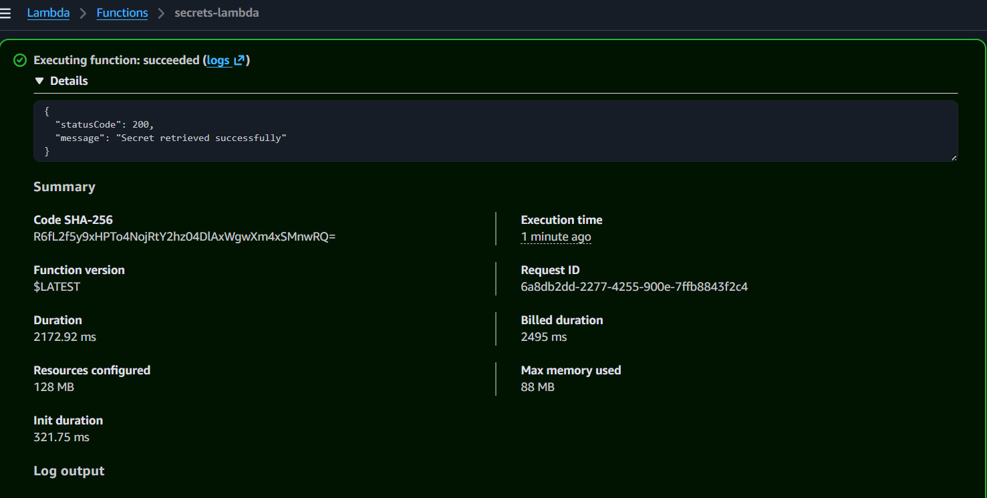
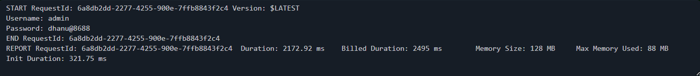
When Lambda function runs these things go to CloudWatch Logs.
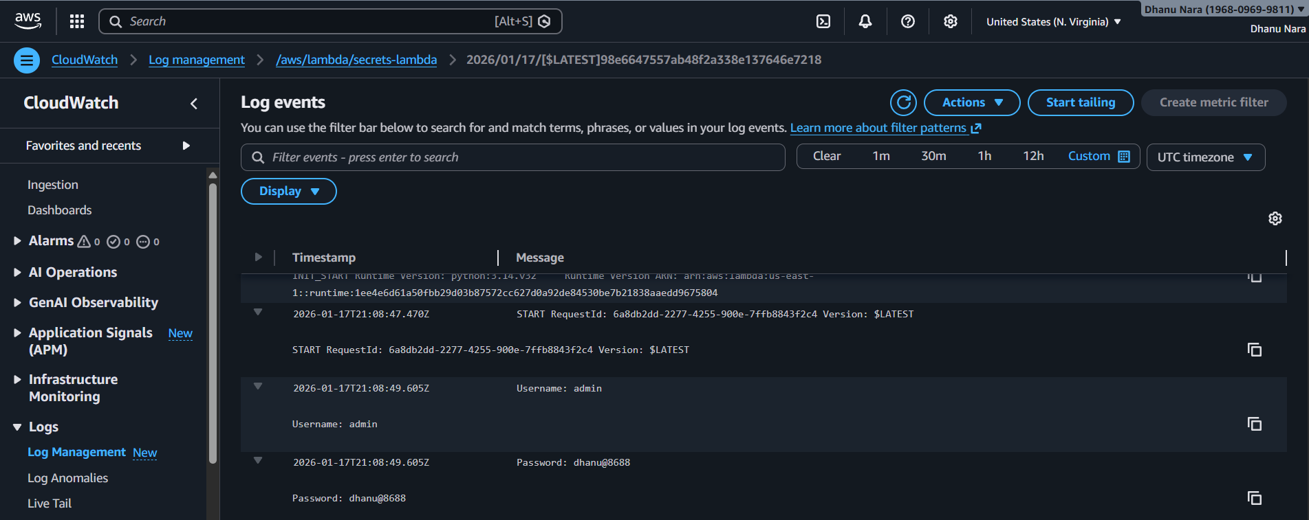

Conclusion
AWS Secrets Manager securely stores sensitive credentials and allows AWS Lambda to retrieve them at runtime without hardcoding secrets in code.
This implementation improves security, supports DevOps best practices, and ensures safer credential management in cloud-based applications.

